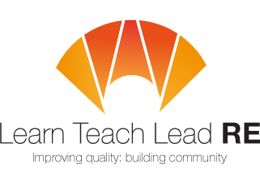

The third Bristol RE Hub Meeting
Twilight network group for all primary and secondary teachers who teach RE
Monday 15th May 2017 from 4:00-5.30pm
at Westbury on Trym CE Academy, Channells Hill, BS9 3HZ
Hinduism – what do Hindus believe and how might you get this across in a classroom?
Meera Patel is a teacher at Westbury on Trym Academy and practising Hindu. She will be sharing her knowledge and suggestions for bringing this religion to life in the classroom.
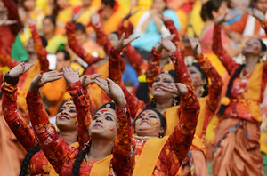



4.00 - 4.15 Arrival and coffee
4.15 -5.00 Guest Speaker – Meera Patel – Westbury on Trym teacher
5.00 – 5.30 Building an AMV friendly resource on Hinduism – bring and share a resource you have taught! (Primary)
Bring and share a resource (Secondary)
RE after Levels – Alice Sarbicki (Secondary)

5.30-6.00 Delivering the new A Level (Secondary)
Parking available on the road opposite the school entrance, or in nearby housing estate, or free car park at the bottom of Channells Hill, near the Primary Care centre.
Free and open to all teachers and HLTAs teaching RE at Primary and Secondary. Everyone is very welcome!
More details : Primary adam.robertson@bristoldiocese.org Secondary emessinger@bristolcathedral.org.uk
Hubs are affiliated to the National Association of Teachers of RE ​www.natre.org.uk/
For further details of our programme and its partners, please visit our website ​www.ltlre.org

