Plymouth RE Conference
12th May 2017 –The Copthorne Hotel

Plymouth RE conference is back for its third year. This year, Lat Blaylock will be joined by Deborah Weston O.B.E.
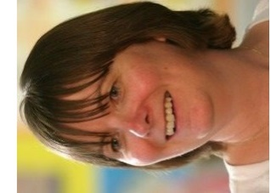
Only
£110

Deborah Weston is an experienced teacher and trainer who works in a large inner city school as Director of SMSCD. Deborah is involved in the training of teachers in RE in the primary and secondary phases, both in ITE and CPD. She supports classroom practitioners and also advises four local authorities on a regular basis. She is the Chair of the PR Group, a Director of the Religious Education Council, a member of the national executive of NATRE (the National Association of Teachers of RE) and a trustee of the Culham St Gabriel’s Trust. Amongst other projects, Deborah has worked with the DfE as their drafter for the reformed GCSE and A level subject content.
REToday
resources
on sale
A Brief outline of the day
Keynote from Deborah Weston O.B.E – RE teachers CAN make a difference
What does deep learning look like in RE for 5, 7, 9, 11 year olds
How to approach a religion for deeper learning – Hinduism
Boost your subject knowledge of Shi’a Islam (KS1, 2 and 3)
What is the connection between deep learning and creativity? -Poetry / Dance / Drama / Art / Forest
For further details, please contact Katie.freeman@stmatthewsstcmat.org
Lat was fantastic, I am leaving with so many ideas that I can use in my classroom.
RE Conference 2016

Lunch
included

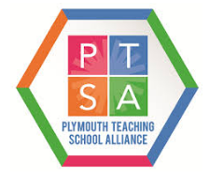
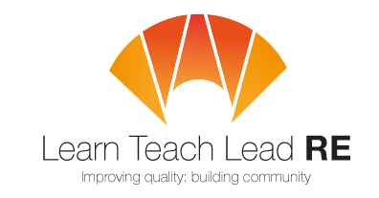
PTSA working with LTLRE

