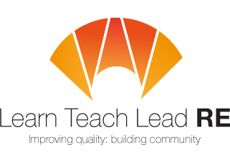

AN INVITATION
to the Taunton Area RE Hub Meeting
termly twilight network group for primary and secondary teachers of RE
Tuesday 13th June 2017
4:00-5:30pm


Heathfield Community School, Taunton TA2 8PD

Are you a teacher of RE looking for ideas, support and inspiration?
Agenda:
- Primary focus: Introduction to Philosophy 4 Children
- Secondary focus: updates and resources for new GCSE spec courses
Refreshments available on arrival
Free and open to all teachers and HLTAs teaching RE at Primary and Secondary. Everyone is very welcome!
More details : ktaylor3@educ.somerset.gov.uk or michael.s.keogh@gmail.com
Book now for the LTLRE conference in Bath on 29/30th June
(details on home page of http://ltlre.org)

Hubs are affiliated to the National Association of Teachers of RE ​www.natre.org.uk/
For further details of our programme and its partners, please visit our website ​www.ltlre.org
LTLRE hubs are funded through an award from The Jerusalem Trust and St Matthias Trust

