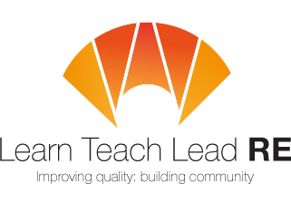

Bristol RE Hub Meeting
Twilight network group for all primary and secondary teachers who teach RE
Tuesday 26th September 2017 from 4:15 - 5.30pm
at Bristol Cathedral Choir School, BS1 5TS
Christianity


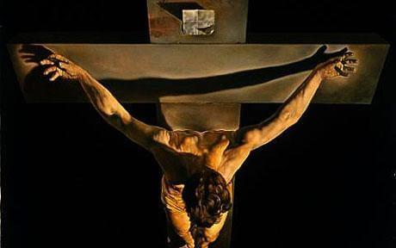
Lucy Nagel has been a Secondary teacher of RE in Bristol, and is now a curate at Redland Parish Church. She will be drawing on these experiences to build up our knowledge and understanding of Christianity.

4.15 - 4.30 Arrival and coffee
4.30 -5.00 Guest Speaker – Lucy Nagel – Curate and teacher
5.00 – 5.30 Secondary - National Updates and information, Claire Anderton from Bristol Free School 'Good RE & the Holocaust'

There are plenty of car parks, possible bus routes and bike hoops. Free parking will be confirmed as soon as possible, but please contact Esther if there are any accessibility issues.
Free and open to all teachers and HLTAs teaching RE at Primary and Secondary. Everyone is very welcome!
More details : Primary adam.robertson@bristoldiocese.org Secondary emessinger@bristolcathedral.org.uk
Hubs are affiliated to the National Association of Teachers of RE ​www.natre.org.uk/
For further details of our programme and its partners, please visit our website ​www.ltlre.org

