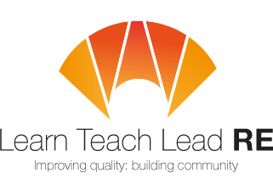

Bristol RE Hub Meeting
Twilight network group for all primary and secondary teachers who teach RE
Thursday 1st March 2018 from 4:15 - 5.30pm
at Andalusia Academy, St Matthias Park, Bristol, BS2 0BA
Islam – Teaching it in the classroom
Ridwan Hussain is a Secondary teacher of RE at Andalusia Academy, an independent school with an Islamic ethos. He will be talking about issues and concepts in Islam – and what it means to be a Muslim in modern Britain.
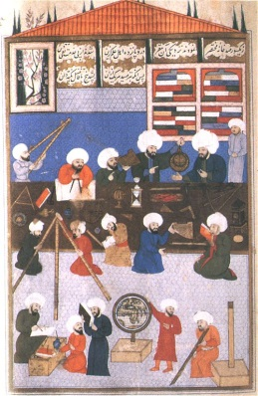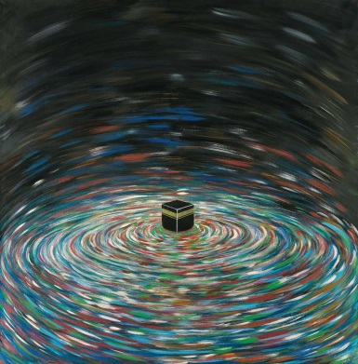
4.15 - 4.30 Arrival and coffee
4.30 -5.00 Guest Speaker – Ridwan Hussain –teacher
5.00 – 5.30 Split into Primary and Secondary - National Updates and information. Some ‘take-away’ ideas for you to try.

The nearest car park is Cabot Circus (5 mins walk from the school). There is limited metred on-street parking.
Free and open to all teachers and HLTAs teaching RE at Primary and Secondary. Everyone is very welcome!
More details : Primary - Adam at adam.robertson@bristoldiocese.org
Secondary – Alice at asarbicki175@redlandgreen.bristol.sch.uk
Hubs are affiliated to the National Association of Teachers of RE ​www.natre.org.uk/
For further details of our programme and its partners, please visit our website ​www.ltlre.org

