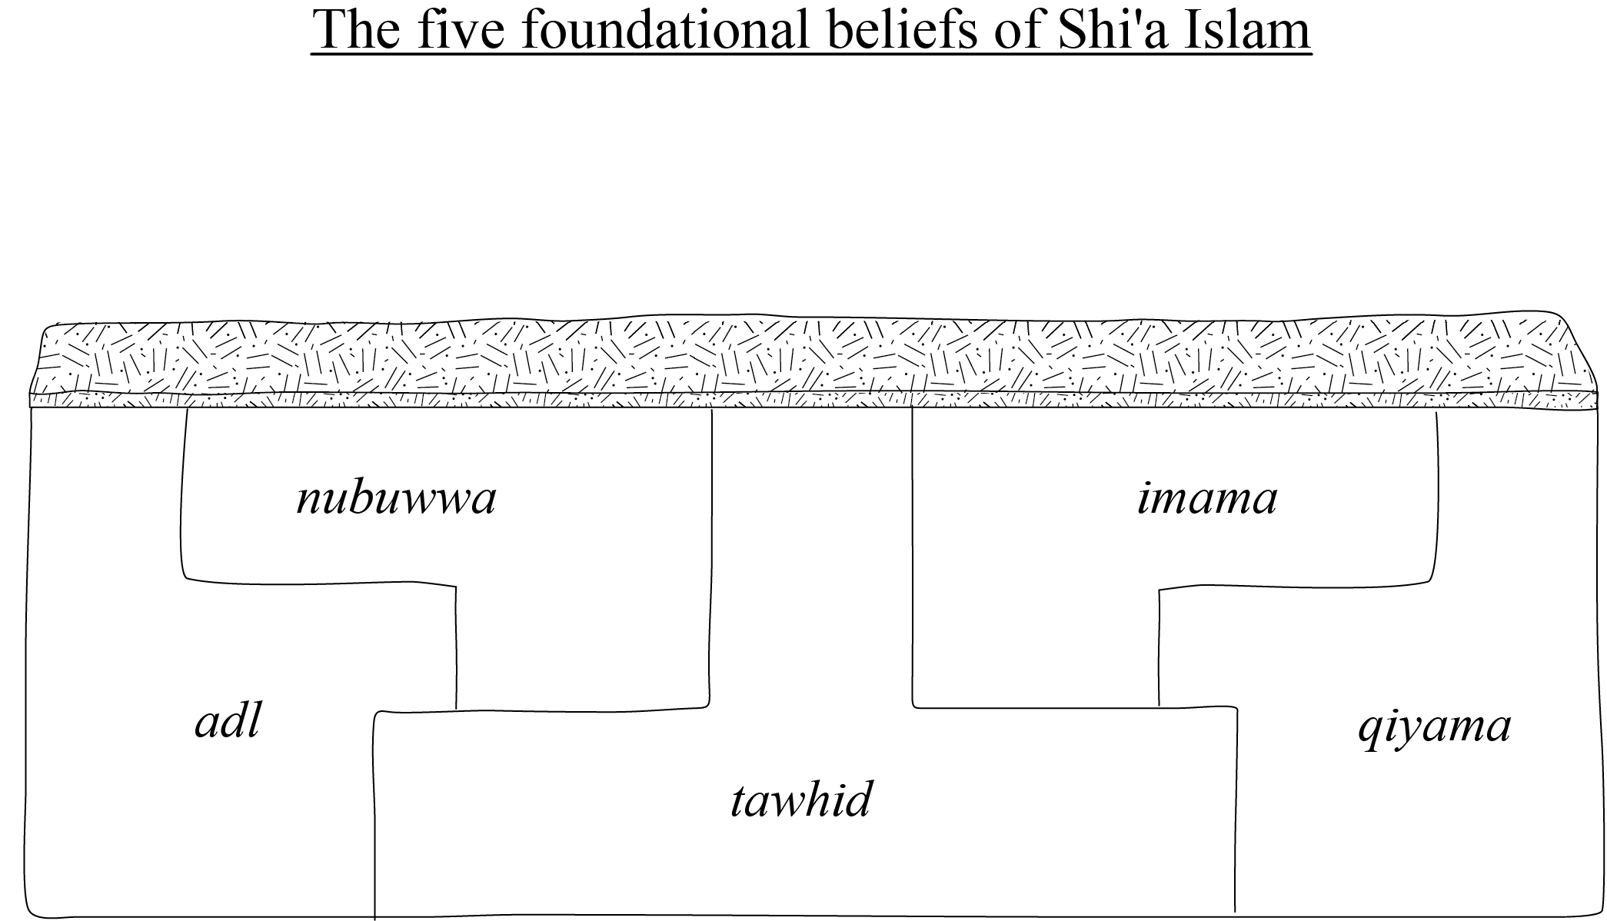

There are five foundational beliefs that underlie the practice of Islam in Shi'a understanding. These are: tawhid, the oneness of God; adl, the justice of God; nubuwwa, prophethood; imama, divinely inspired leadership; and qiyama, resurrection, judgement and life after death. The model that is given is of five foundation stones on which the practice of Islam can be built. The central foundation is tawhid and all the others rest on this. The five fit together or tessellate so that none can stand without the other four. All five contribute to form the foundation layer on which the pillars, practices or obligatory acts of Islam in Shi'a understanding stand.

For full text please see: www.chrishewer.org – GCSE Religious Studies: Islam – Beliefs and Teachings – Five foundational beliefs of Shi'a Islam.

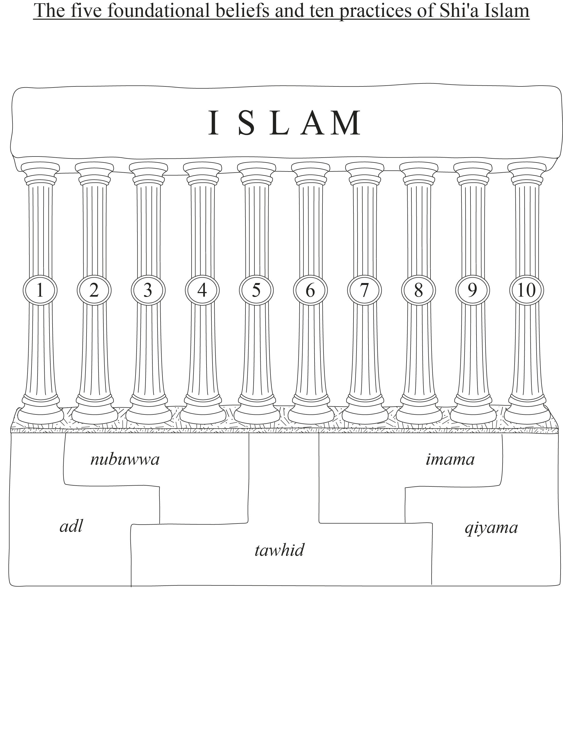

These ten obligatory acts are:
- Salat, the regular rhythm of five times per day formal prayer.
- Sawm, fasting during the month of Ramadan.
- Hajj, the annual pilgrimage to Makka, which is obligatory on every adult Muslim once in their lifetime if they have sufficient wealth and health to perform it.
- Zakat, the circulation of a proportion of one’s surplus wealth to those in need.
- Khums, a 20% per annum social welfare contribution.
- Jihad, striving in the way of God.
- Amr bil maruf, seeking to promote the good within society.
- Nahy anil munkar, opposing the bad within society.
- Tawallah, love and respect for God, the Prophet and the Ahl al-Bayt (the Family of Muhammad).
- Tabarra, keeping away from those who are ungodly and unjust to the Prophet and the Ahl al-Bayt.

For full articles on each please see: www.chrishewer.org – GCSE Religious Studies: Islam – Practices (then Prayer, Fasting, Money, Pilgrimage and Striving in the way of God) – Forms of expression and ways of life (then Shi'a obligatory acts).

