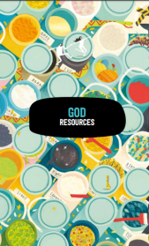
Y1 Creation
Who made the world?

What will we be learning?
- How to tell the story of Creation from Genesis 1:1-2.3
- That creation is the start of the Bible.
- What Christians do to say thank you to God for the Creation.
- We will be thinking and asking questions about living in an amazing world.

Key knowledge
- God created the universe.
- The Earth and everything in it are important to God.
- God has a special relationship with human beings as their Creator and Sustainer.
- Humans should care for the world because it belongs to God.

Key Vocabulary
Genesis
Christian
God
Creation
Bible
Things to think about…
If God made the world, how should people live? What do you think? One way is by being thankful to God, the Creator.

