Chestnuts y1-2 Why does Christmas matter to Christians?
Key vocabulary – star words | What will we be learning?
Christian  Bible  New Testament  Incarnation  Nativity  Carols  Wise men  Shepherds  Angels | - Recognise that Incarnation is part of the ‘Big Story’ of the Bible.  - Tell the story of the birth of Jesus and recognise the link with Incarnation — Jesus is ‘God on Earth’  - Christians believe Jesus came for both rich and poor  - Christmas carols tell the story of Christmas and the meaning of Christmas  - There are many things in our Nativities which are not in the Bible  - For Christians, Christmas is a time for giving
Things to think about | Key knowledge
Christians believe that Jesus was born among poor and marginalised people. Where might he be born now?  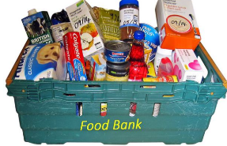  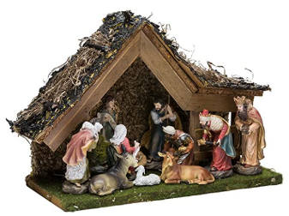  Christmas is about giving – how could you help people in need? | - Christians believe that Jesus is God and that he was born as a baby in Bethlehem.  - The Bible points out that his birth showed that he was extraordinary (for example, he is worshipped as a king, in Matthew) and that he came to bring good news (for example, to the poor, in Luke).  - Christians celebrate Jesus’ birth; Advent for Christians is a time of getting ready for Jesus’ coming.  - Jesus was born among poor and marginalised people

