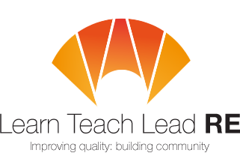

AN INVITATION TO
Secondary LTLRE Hub Meeting
twilight network group
4.00-5.15pm Wednesday 29th June 2022
Zoom link: https://us02web.zoom.us/j/89631223831
Suzannah Strong: Developing high quality RE at KS4
This workshop will explore ways schools can provide rigorous, high quality RE at Key Stage 4, looking at curriculum aims, content decision-making and assessment
Suzannah is Head of RE and PSHE, SMSC lead and oracy advocate at Redruth School. @suzannahstrong

Free and open to all teachers and HLTAs teaching RE at Primary and Secondary. Everyone is very welcome!
More details: efpawson@gmail.com
Hubs are affiliated to the National Association of Teachers of RE ​www.natre.org.uk/
For further details of our programme and its partners, please visit our website ​www.ltlre.org
LTLRE hubs are funded through an award from The St Luke’s College Foundation. www.stlukesfoundation.org.uk/

