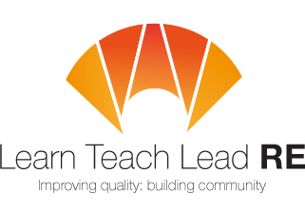
AN INVITATION TO
The LTLRE
North Devon
RE Hub Meeting
Twilight RE Network Group

16.00 – 17.15 on Monday 24th November 2025
Online Meeting

LTLRE Conference feedback and input:
- Ways of knowing
- Storytelling in RE
- Oak Academy resources for RE
- Great RE at KS4
Come along and meet RE teachers from across the area. A place to discuss ideas, share resources and ask questions. Break out rooms according to Primary/Secondary.


Free and open to all teachers and HLTAs teaching RE. Everyone is very welcome!
Please RSVP using this link: https://forms.office.com/e/VGEVqCzY3B
Join us on Teams: Learn Teach Lead RE Hub meeting | Meeting-Join | Microsoft Teams

Deb Spelman dspelman@ilfracombe-jun.devon.sch.uk
Zoe Bullamore zbullamore@ilfracombeacademy.uk

Hubs are affiliated to the National Association of Teachers of RE ​www.natre.org.uk/
For further details of our programme and its partners, please visit our website ​www.ltlre.org
LTLRE hubs are funded through an award from The St Luke’s College Foundation. www.stlukesfoundation.org.uk/

