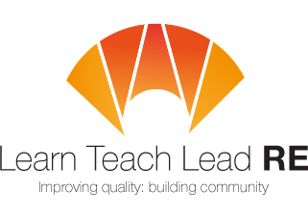




AN INVITATION TO
LTLRE
South Devon and Torbay Hub
Primary and Secondary Hub Meeting

Twilight RE Network Group
4:00-5.00pm on Thursday 13th November 2025, virtual

Oak Academy, AS and GCSE exam board mapping
A session to explore resources by the Oak Academy, ways in which to map these to the new Torbay & Devon Agreed Syllabus and a look at GCSE exam board mapping.
We will also share pointers and hacks from the recent LTLRE Area 1 Conference 2025: Embracing Diversity and Inclusion through a Religion and Worldviews approach to RE.

Before the meeting, please sign up here: https://forms.gle/jZsc4wW2rmai5jXM9

Join Zoom Meeting https://us02web.zoom.us/j/84116473634
Meeting ID: 841 1647 3634

Free and open to all teachers and HLTA teaching RE/RS.
Everyone is very welcome!

For more details, please contact us
Belinda Twiggs (Primary) belinda.twiggs@stmichaels.education
Laura Twamley (Primary) ltwamley@kingskerswell.devon.sch.uk
Shelley Moss (Secondary) shelley.moss@churstongrammar.com

Hubs are affiliated to the National Association of Teachers of RE ​www.natre.org.uk/
For further details of our programme and its partners, please visit our website ​www.ltlre.org
LTLRE hubs are funded through an award from The St Luke’s College Foundation. www.stlukesfoundation.org.uk/

