Plymouth LTLRE and NATRE
RE Hub Meeting
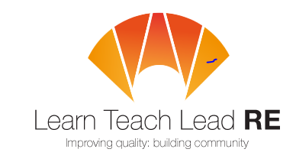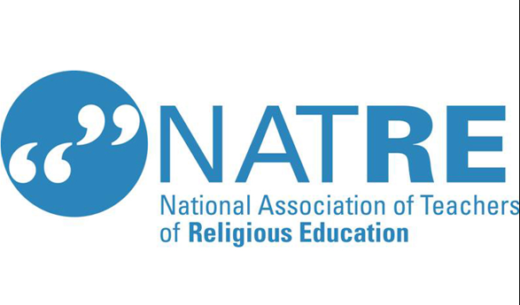
Where? Online – Please email to book your place and receive the meeting link.
Theme: The RE Curriculum – The Curriculum and Assessment Review recommendations.
In this session, we will be looking at The Curriculum and Assessment Review recommendations for Religious Education. We will be discussing what this means for our subject, sharing what might happen next and discussing what it might mean to enter the National Curriculum. We will also be talking about the recommendations surrounding examinations and changing the name of the subject..
When? 3rd December 2025
Speakers: Katie Freeman, Ed Pawson and Tracy Davis
Phase: Primary and Secondary
Time? 4 – 5pm
What do I get? Free resources and we will do our best to answer any questions that you may have.
Please book your place via email: kfreeman@bickleighdown.devon.sch.uk

