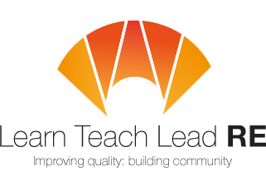

AN INVITATION TO
LTLRE Devon Primary Hub Meeting
Twilight RE Network Group

4:00-5.15pm on Tuesday 19th May 2026
Topic: Growing up Sikh in Devon today
with Simran Singh (student at Torquay Boys Grammar School)

Zoom link: https://us02web.zoom.us/j/88350425200
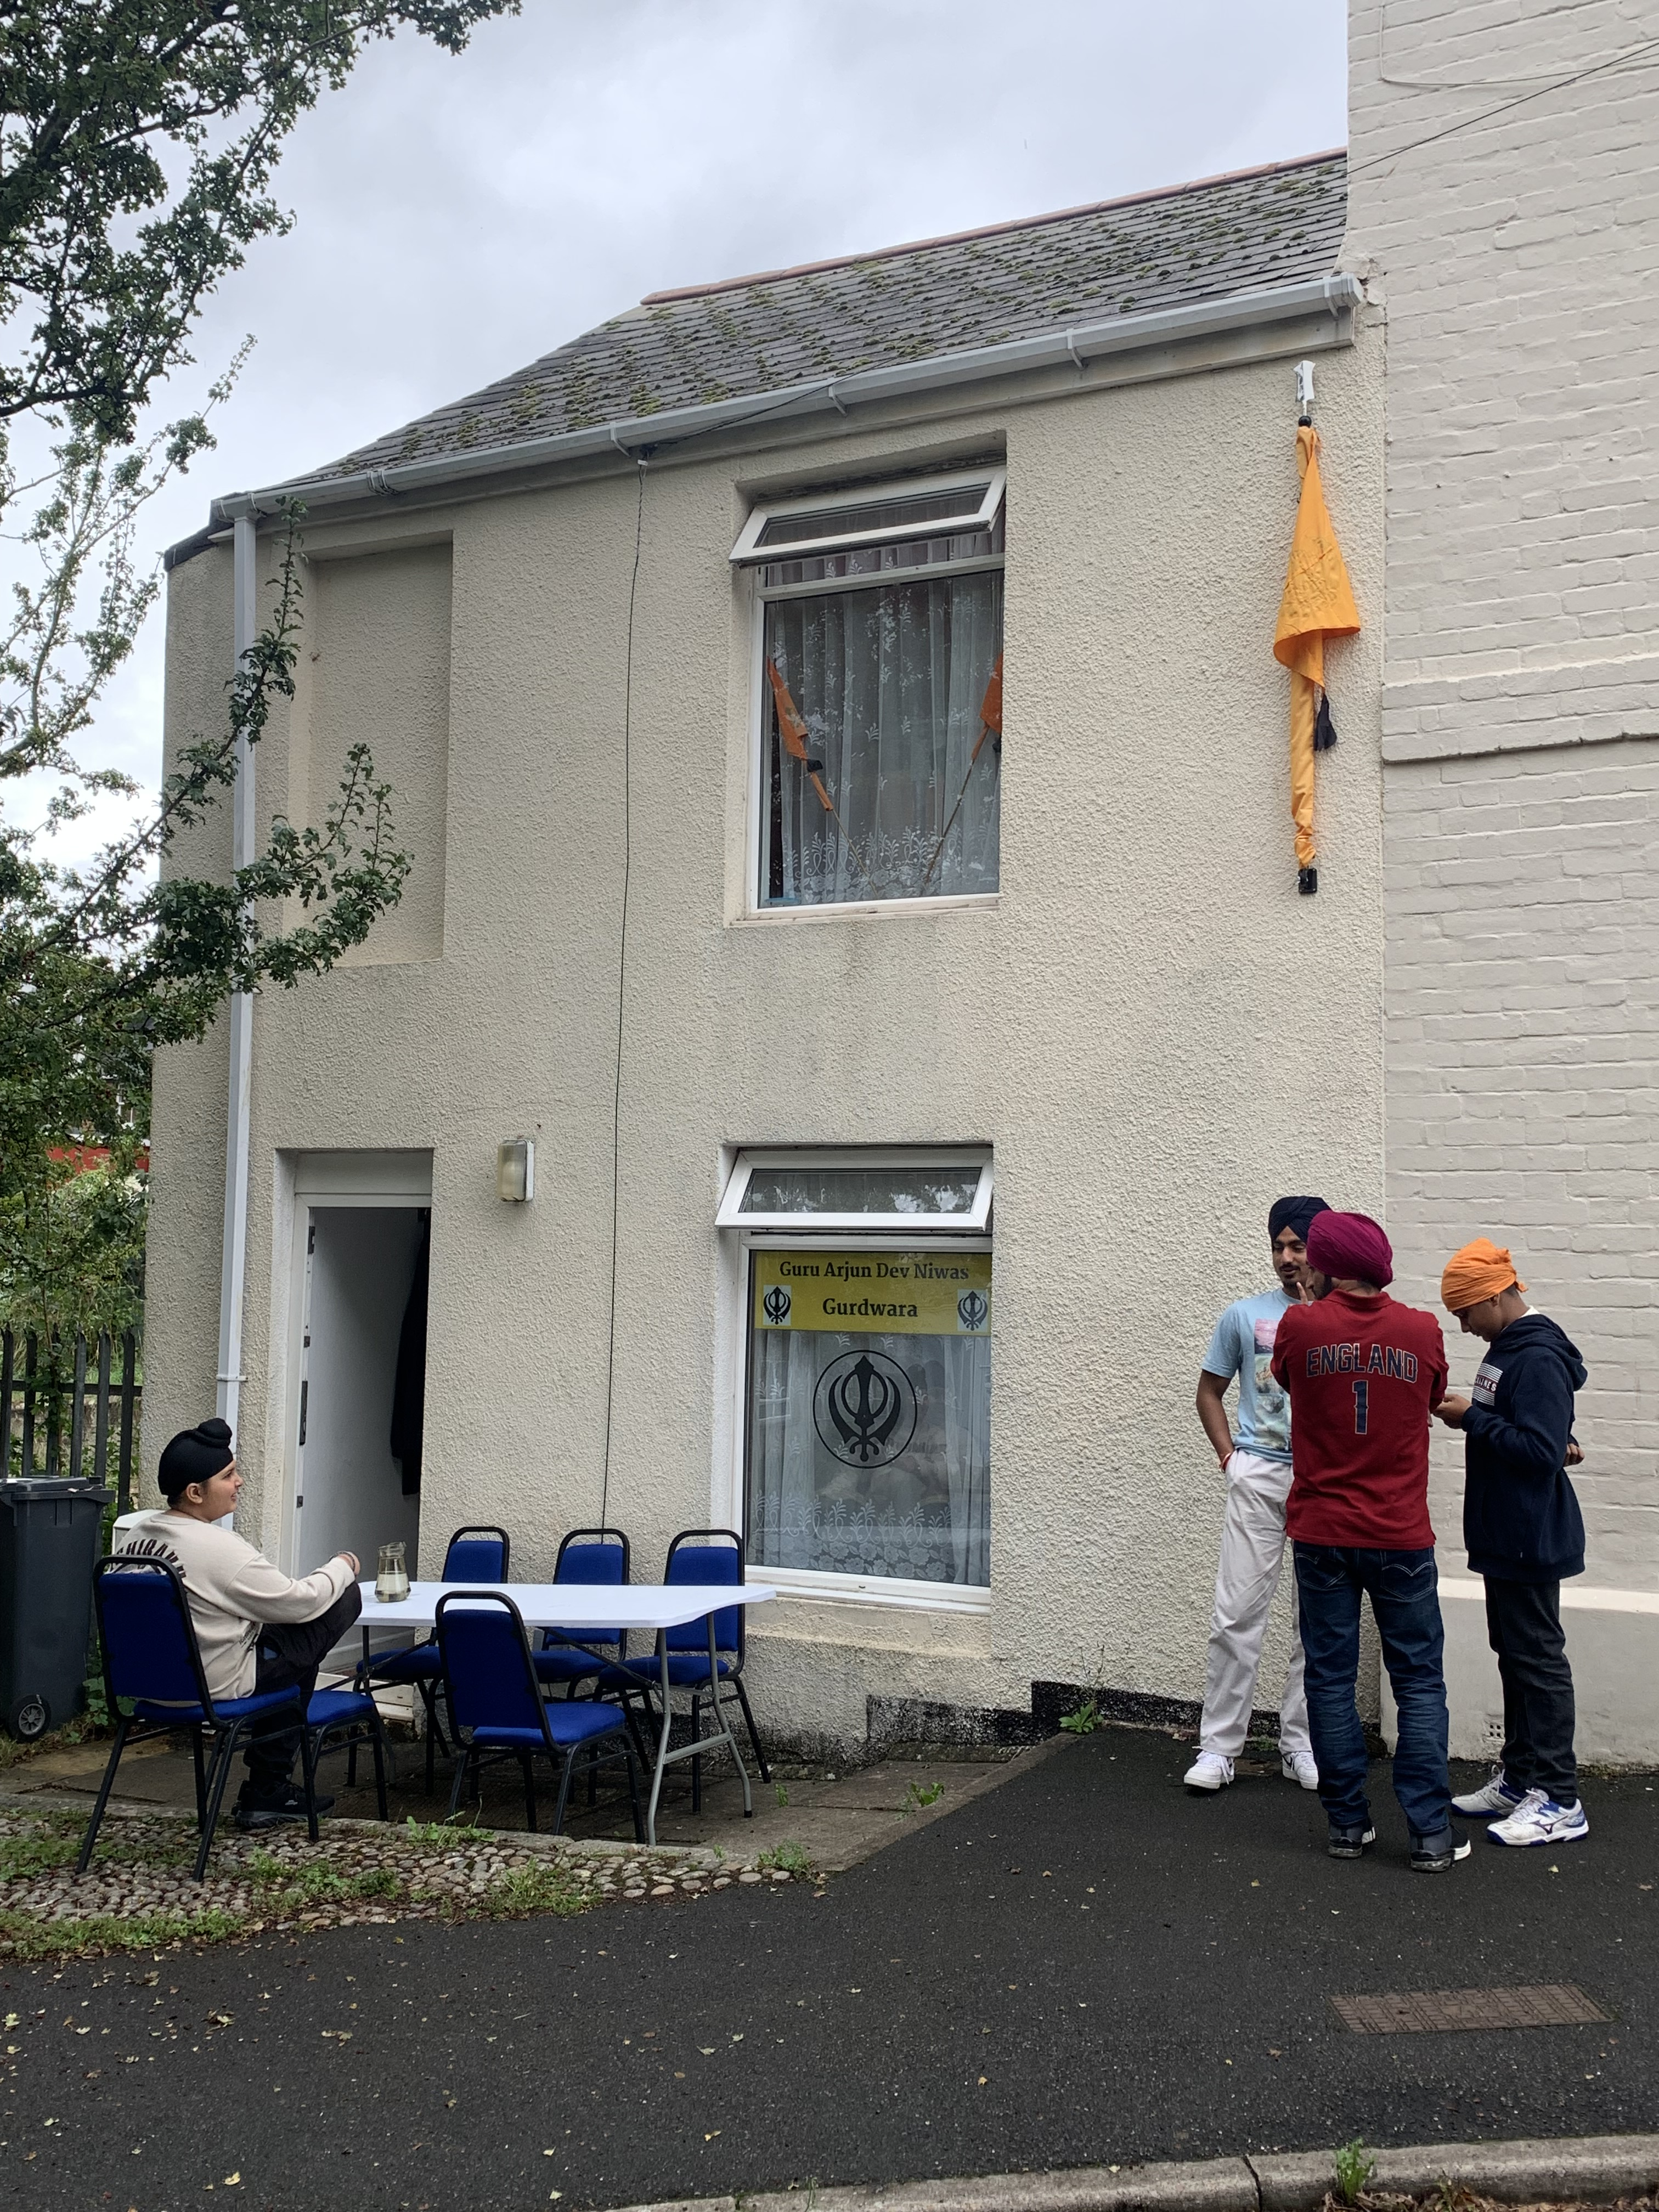
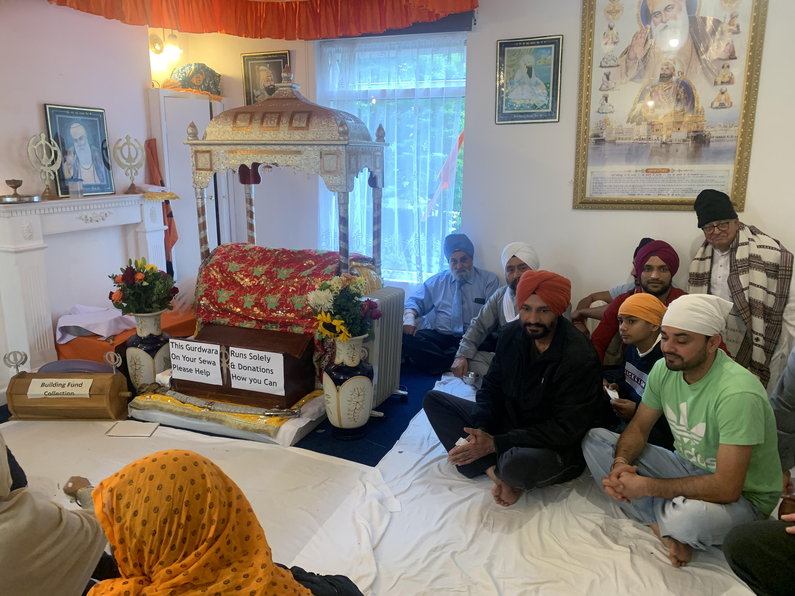

Free and open to all teachers and HLTAs teaching RE. Everyone is very welcome!
More details: Ed Pawson efpawson@gmail.com

Hubs are affiliated to the National Association of Teachers of RE ​www.natre.org.uk/
For further details of our programme and its partners, please visit our website ​www.ltlre.org
LTLRE hubs are funded through an award from The St Luke’s College Foundation. www.stlukesfoundation.org.uk/

