Free Christian Books for School Libraries

Over 500 Library boxes of Christian books have gone out to schools already.

Bridge Books in Exeter is committed to making sure each school is offered Christian books for their library at least once every five years, so that there are quality Bible Storybooks, Graphic Bibles, Christian Biographies, and other helpful books about the Christian faith for children to borrow. These are specifically for a Library situation and we normally offer £250 worth of books per Primary school and £500 per Secondary School. We rely on donations for this purpose and aim to fulfil requests as soon as funds are available.
Library Boxes can of course be purchased from us at any time.
Would you like a Library Box for your School library? Contact Mary and Gary at sales@bridgebookshop.co.uk or call 01392 427171.
Would you like to donate towards a Library Box? Donations can be made by bank transfer to ‘Bridge Books Library Fund’ 08-92-50 Acc 68545510. Or call 01392 427171 and pay by card, or send a cheque to ‘Bridge Books Library Fund’ to 3 Okehampton Steet, Exeter, EX4 1DW.
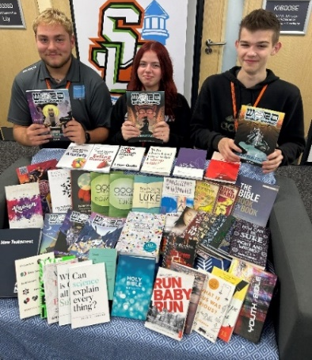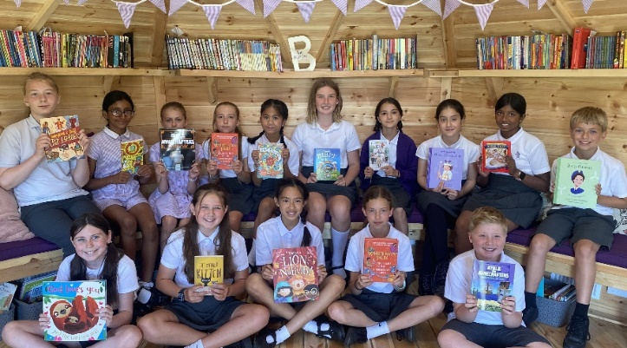
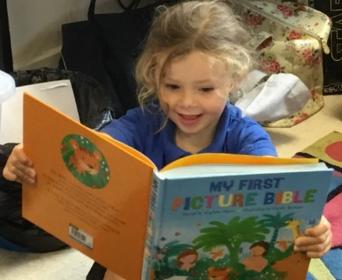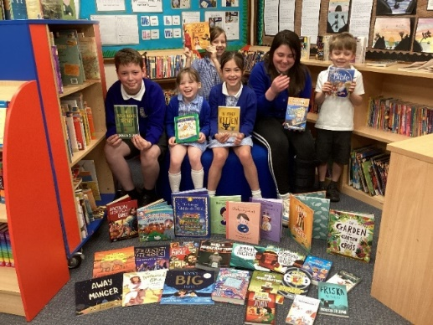
PS Remember us when you need Class Bibles or other Christian resources and we will give you a quote. Bridge Books, Exeter sales@bridgebookshop.co.uk or call 01392 427171.

